**Fake news detection using NLP**

**By**

**Thenamuthan V**

**711121106084**

**INTRODUCTION:**

In an age characterized by an overwhelming influx of information and the rapid dissemination of news through digital channels, the veracity of the information we encounter has become increasingly challenging to discern. The proliferation of fake news, deliberately fabricated or misleading information presented as fact, poses a significant threat to the integrity of our information ecosystem. Fortunately, the fields of Natural Language Processing (NLP) and artificial intelligence have risen to the challenge, offering innovative tools and techniques to combat this menace.

**CODING AND PREPROCESSING:**

**Data Cleaning:**

This involves handling missing values, dealing with outliers, and resolving inconsistencies in the data.

**Data Transformation:**

This includes scaling, normalization, and encoding categorical variables to ensure that the data is in a suitable format for analysis or modeling.

**Feature Engineering:**

This involves creating new features from the existing data to improve the performance of machine learning models.

**Code:**

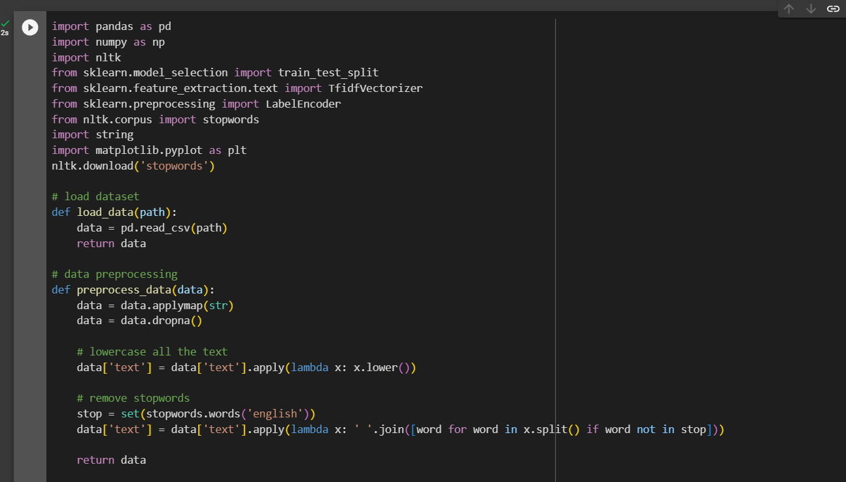

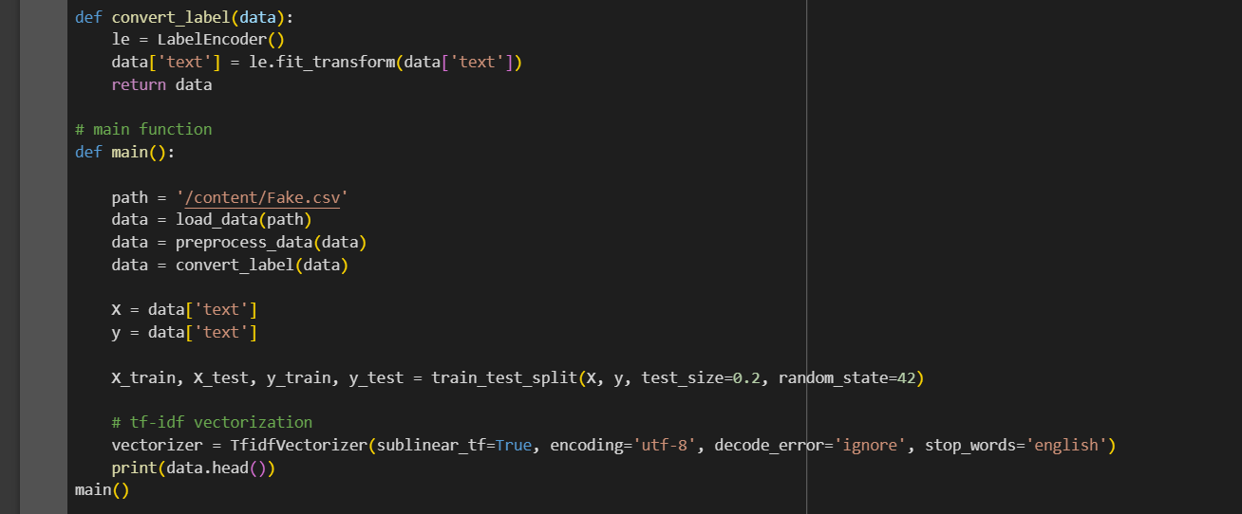

**EXPLANATION:**

* In this code the dataset has been loded
* Then the given data is get processing
* Lowercasing all the texts and removing the stop words
* We have use le as lable encoder,call the main fuctions to get the data

**Output:**

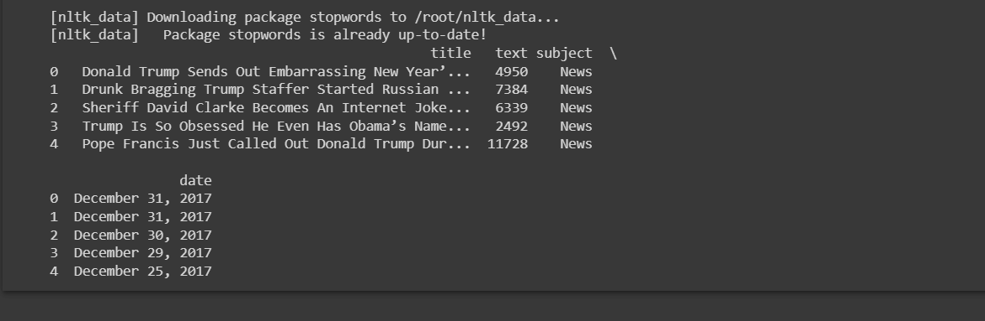

Thus the above code is verified and executed successfully